**Social Media Kit**

EdRedesign’s Institute for Success Planning

Summer Workshop for Community of Practice: Welcoming the Inaugural Cohort

#SuccessPlanningWorkshop2022

July 18-20, 2022

**TWITTER SUGGESTED TEXT & IMAGES:**

**Handle: @EdRedesignLab**

[.@EdRedesignLab](mailto:.@EdRedesignLab) @hgse has two exciting updates: the initial cohort of cross-sector teams from across the country has joined its Success Planning Community of Practice AND their Institute for Success Planning welcomed Tauheedah Jackson as its new director! Read the press release: <https://bit.ly/3MhNB5E> #SuccessPlanningWorkshop2022

.@EdRedesignLab @hgse's Institute for Success Planning will work to ensure ALL kids have clear & accessible pathways to opportunity. It will collaborate w/ 12 communities to design systems that integrate kids’ ed & developmental needs: <https://bit.ly/3MhNB5E> #SuccessPlanningWorkshop2022

Out-of-school factors explain most variance in ed attainment. Yet, equity efforts have focused on what happens in school. @EdRedesignLab’s Institute for Success Planning, through its work w/ 12 communities, advances a broader model of opportunity for kids: <https://bit.ly/3MhNB5E> #SuccessPlanningWorkshop2022

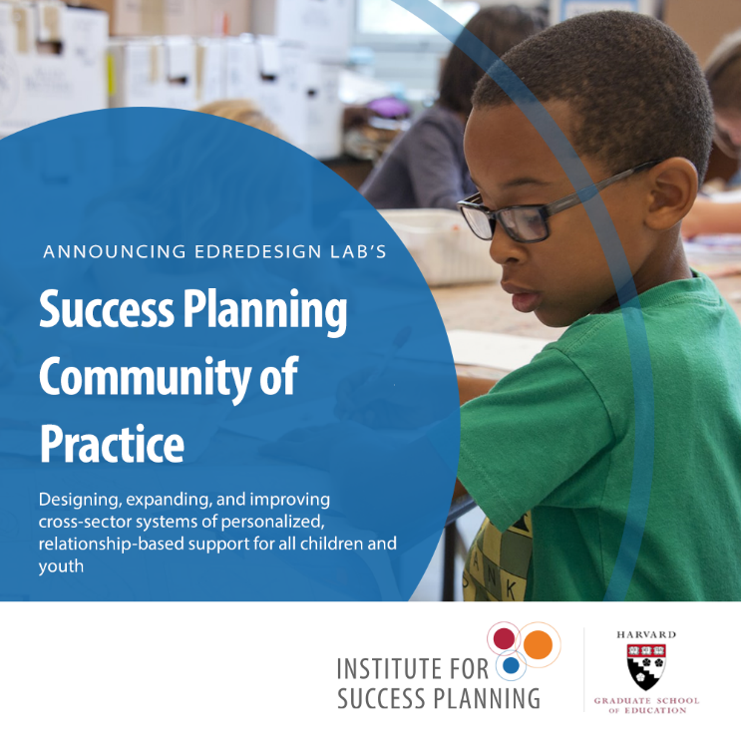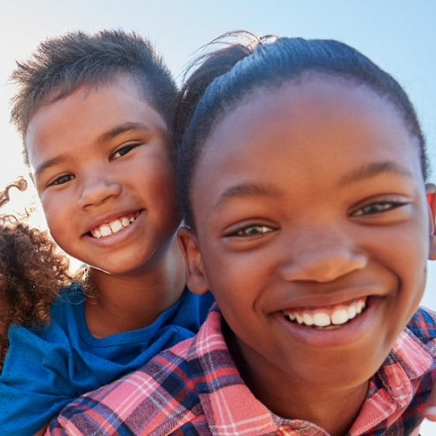

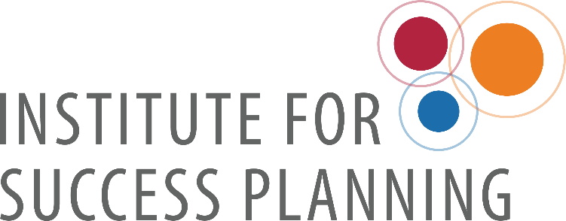

**FACEBOOK SUGGESTED LANGUAGE & IMAGES:**

**Handle: @EdRedesignLab**

@EdRedesignLab @HarvardEducation has two exciting updates to share! Their Institute for Success Planning has announced the inaugural cohort of communities with whom they’ll work to design, expand, and improve cross-sector systems of personalized supports AND they’ve hired cross-sector leader Tauheedah Jackson to head the Institute: <https://bit.ly/3MhNB5E> #education #SuccessPlanningWorkshop2022

@EdRedesignLab’s Institute for Success Planning will work to ensure ALL children have clear and accessible pathways to opportunity and success. It will help communities throughout the U.S. design, expand, and improve cross-sector systems that integrate and respond to children’s educational and developmental needs, so that ALL kids have equal opportunity to succeed in school and in life. Read the press release announcing their inaugural community of practice: <https://bit.ly/3MhNB5E> #education #SuccessPlanningWorkshop2022

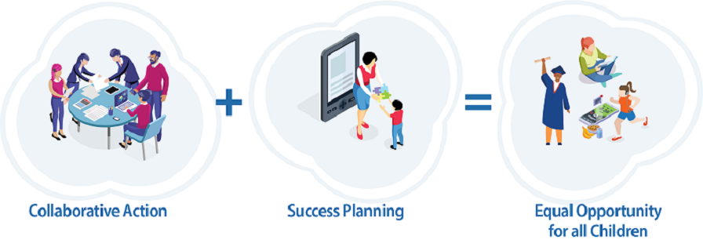Even though factors outside of school explain most of the variance in educational attainment, efforts to achieve equity for children have largely focused on what happens in school. @EdRedesignLab @HarvardEducation seeks to change that by advancing a broader, more holistic model of opportunity for children. EdRedesign has appointed Tauheedah Jackson, a dedicated leader in the cross-sector and personalized supports space, to lead their Institute for Success Planning AND has announced its inaugural cohort of communities! Read the press release: <https://bit.ly/3MhNB5E> #SuccessPlanningWorkshop2022

@EdRedesignLab’s new Institute for Success Planning @HarvardEducation will work to ensure ALL kids have access to high-quality developmental & academic supports & opportunities to set them up for future success. Working with an inaugural cohort of 12 communities, the Institute will join #StudentSuccessPlans and #CollaborativeAction across sectors to deliver on its goals. Read the press release: <https://bit.ly/3MhNB5E> #SuccessPlanningWorkshop2022

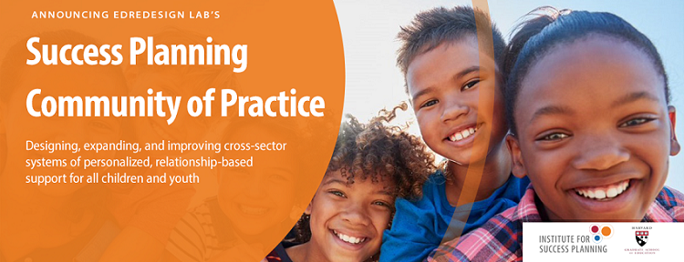



**LINKEDIN SUGGESTED TEXT & IMAGES:**

@EdRedesignLab @HarvardEducation has two exciting updates to share! Their Institute for Success Planning has announced the inaugural cohort of communities with whom they’ll work to design, expand, and improve cross-sector systems of personalized supports AND they’ve hired cross-sector leader Tauheedah Jackson (HGSE Ed.M. ’22) to head the Institute: <https://bit.ly/3MhNB5E> #education #personalizedsupports #SuccessPlanningWorkshop2022

@EdRedesign at the Harvard Graduate School of Education has just announced their inaugural cohort of communities that will participate in the Institute for Success Planning to be headed by Tauheedah Jackson. The Institute will collaborate with communities on the ground to ensure all children have clear & accessible pathways to opportunity: <https://bit.ly/3MhNB5E> #education #personalizedsupports #SuccessPlanningWorkshop2022 #wholechild

@EdRedesign’s new Institute for Success Planning, that launched in March 2022, will work to ensure ALL children have clear & accessible pathways to opportunity. It will collaborate with 12 communities to design systems that integrate and respond to children’s educational and developmental needs, so that ALL kids have equal opportunity to succeed in school and in life. Find out about their inaugural cohort of communities: <https://bit.ly/3MhNB5E> #education #personalizedsupports #SuccessPlanningWorkshop2022

“We are beyond thrilled that Tauheedah Jackson will be at the helm of our Institute for Success Planning, guiding communities in designing personalized, relationship-based systems of support for children and youth through cross-sector collaboration. Tauheedah’s deep experience and wise insights are ideal for leading this initiative to ensure that the talents, interests, and needs of all children, not just some, are supported and nurtured” -Paul Reville, Harvard Graduate School of Education Professor & @EdRedesignLab Director <https://bit.ly/3MhNB5E>

“The Covid-19 pandemic has made clear that schools alone cannot solve the longstanding inequities in opportunities and outcomes for children of different economic and racial backgrounds, as well as for those with learning differences or whose first language is not English. What is exciting about the Success Planning framework is that it represents a paradigm shift that will enable communities to provide children with genuinely equitable opportunities to succeed in school and in life.” -Tauheedah Jackson, Director, Institute for Success Planning @EdRedesignLab <https://bit.ly/3MhNB5E> #education #personalizedsupports #wholechild #SuccessPlanningWorkshop2022

Even though factors outside of school explain most of the variance in educational attainment, efforts to achieve equity for children have largely focused on what happens in school. @EdRedesignLab’s Institute for Success Planning at the Harvard Graduate School of Education will work with a cohort of 12 communities to redesign, expand, and improve cross-sector systems of support and opportunity for ALL children IN and OUT of school. The Institute’s work will advance a broader, more holistic model of opportunity so that all kids, not just some, have a clear and accessible path to success in school and in life. <https://bit.ly/3MhNB5E> #wholechild #education #personalizedsupports #SuccessPlanningWorkshop2022

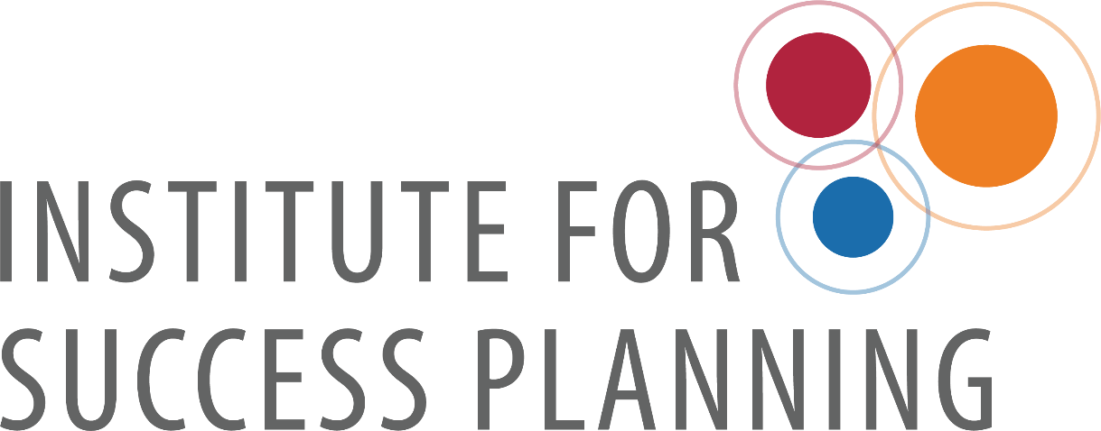

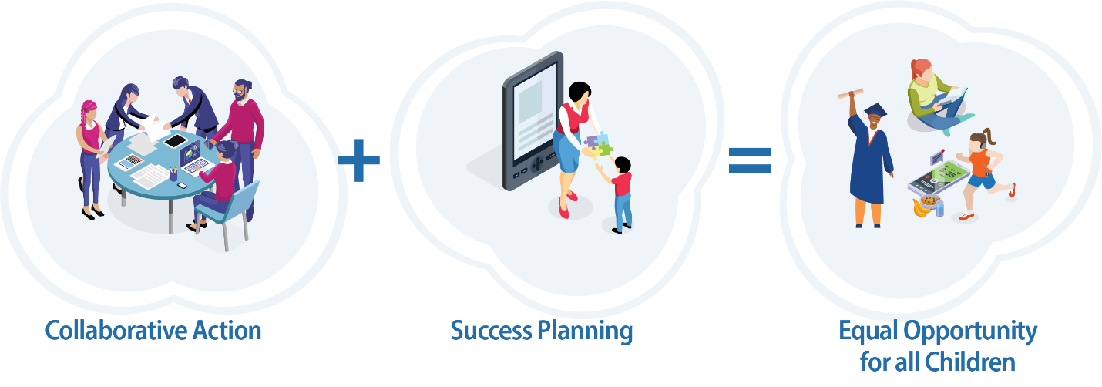

**INSTAGRAM SUGGESTED TEXT & IMAGES:**

**Handle: @edredesignlab**

@edredesignlab has two exciting updates: the initial cohort of cross-sector teams from across the country has joined its Success Planning Community of Practice AND their Institute for Success Planning welcomed Tauheedah Jackson as its new director! #wholechild #SuccessPlanningWorkshop2022

@edredesignlab's Institute for Success Planning will work to ensure ALL kids have clear & accessible pathways to opportunity. It will collaborate with 12 communities to design systems that integrate kids’ educational & developmental needs. #wholechild #SuccessPlanningWorkshop2022

Out-of-school factors explain most variance in educational attainment. Yet, equity efforts have focused on what happens in school. @edredesignlab’s Institute for Success Planning, through its work with 12 communities, advances a broader model of opportunity for kids. #wholechild #SuccessPlanningWorkshop2022



**Suggested social media accounts to mention:**

@BarrFdn

@Harvard

@hgse

@PaulReville

@AspenEdSociety

@hczorg

@forumfyi

@FundOurKids

@CAPEarlyEd

@NAESP

@NextGenLC

@Aurora_Inst

@EdElements

@InkHousePR

@E_Sheninger

@knowledgeworks

@StudentCntrHub

@FutureEdGU

@BostonGlobe

@GlobeEducation

@BosPublicRadio

@educationweek

@the74

@hechingerreport

@CommonWealthMag

@Chalkbeat